Measuring Forces On a Wing
- KS4 Science Student Worksheet
Aims
- Practically measure force of lift on a wing
- Explain using vectors that when a wing is in steady state the forces on the wing are balanced
- Be able to explain how a wing creates lift
- Introduce students and teachers to the sport of gliding

Equipment and materials required
The following will be required for each student, or each group of students.
- Pre-assembled “wing-balance” apparatus **
- Blu tack
- Hair drier
- Balance (accurate to 0.1g)

** For instructions on how to build the wing balance see teachers’ notes
What you do

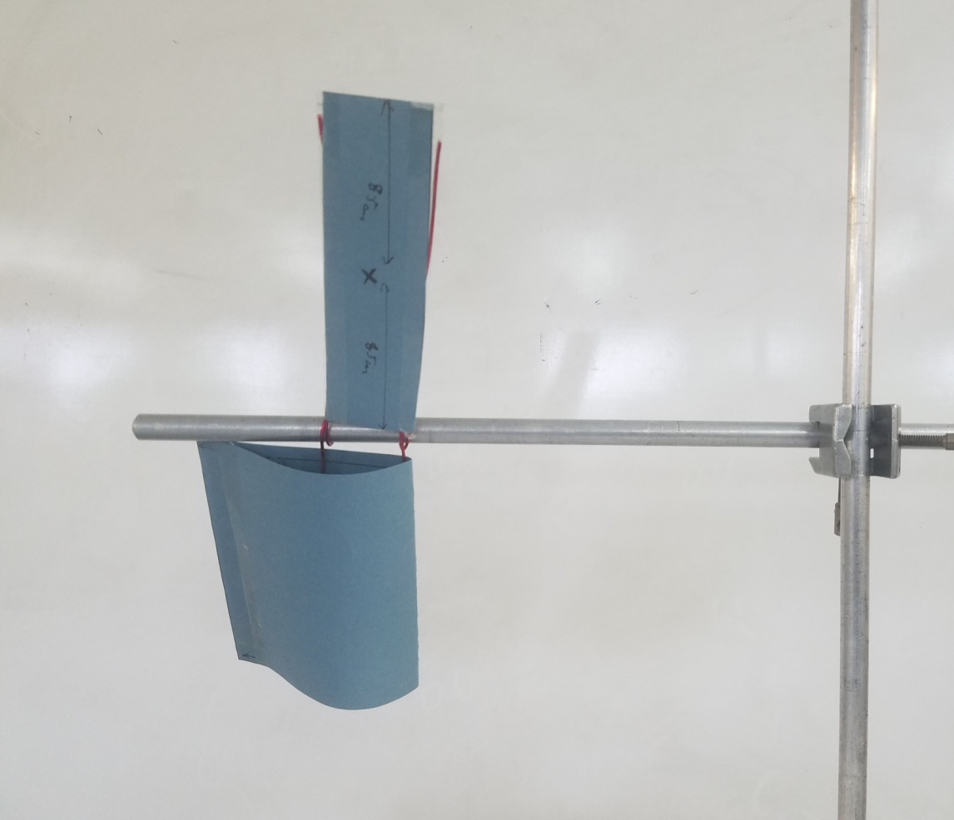
- Assemble the wing profile as shown in the photo below. The wing part of the balance should be below the platform.

Platform
Wing

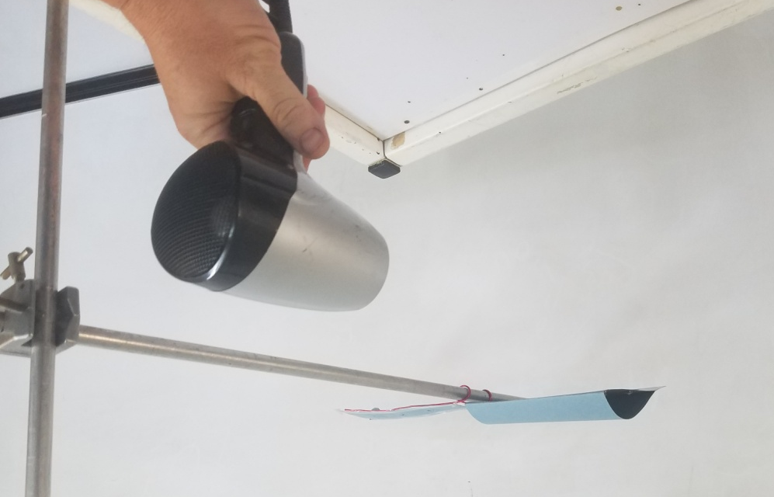
- Use the hair dryer to blow air directly at the front “leading edge” the wing – do not blow from the top or bottom. The wing when air is blowing over the wing should be level. See photo below.

Aim hairdryer at the middle
of the “Leading Edge”

- Possible problems
  - Wing doesn’t lift much?
    - Add some Blu tac to the underneath of the platform.
    - Hold the hair dryer a little closer and blow directly at the front of the wing.

  - Wing lifts too high?
    - Remove some Blu tac from underneath the platform.
    - Do not blow the wing from below.

  - Wing lifts erratically?
    - Make sure the hairdryer isn’t too close to the wing and you are blowing directly at the front “leading edge” of the wing.

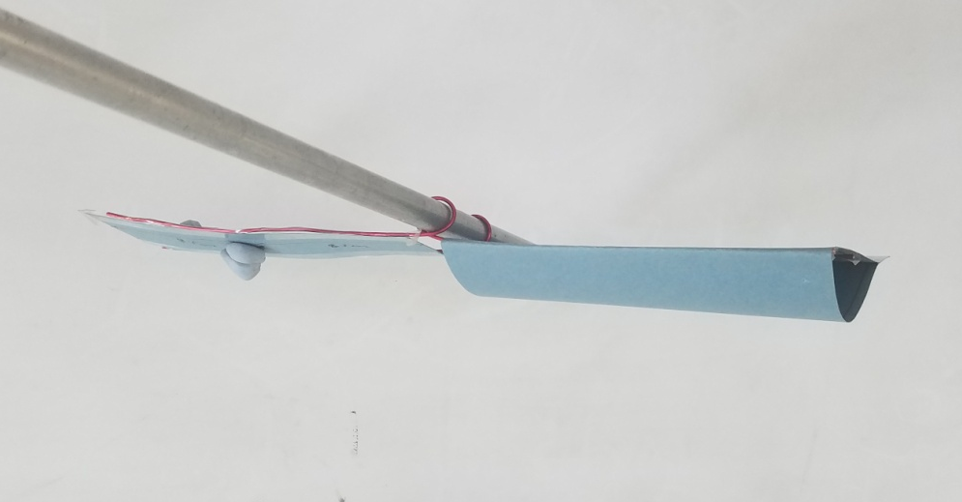
- Turn off the hair dryer and this time balance the wing using Blu tac. To do this add just enough Blu Tac to the cross on the platform so the platform and wing are level.

Blu Tac

- Remove the Blu Tac from the platform and weigh it

Mass of Blu Tac = …………………………… grams

Theory and Calculations
In this practical you have balanced the wing using 2 different methods

Method 1: Balanced the wing by blowing air over it with the hair dryer
Method 2: Balanced the wing by adding Blu Tac to the platform

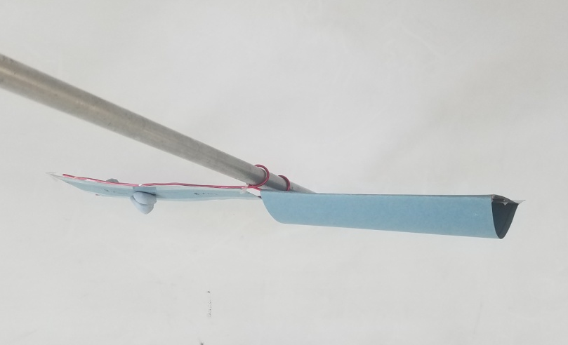
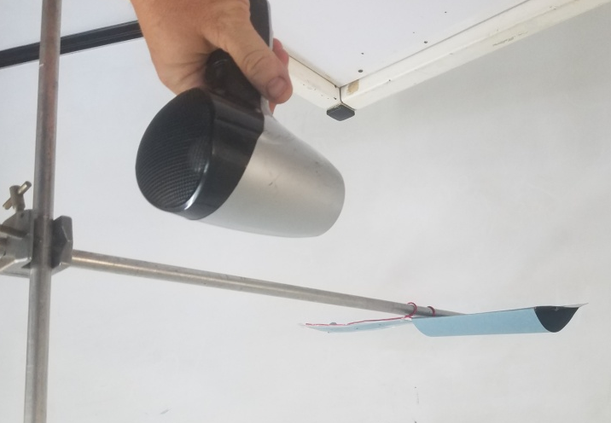
Method 1 Method 2
In both methods when the wing is balanced the force on both sides of the balance is equal
The force created by the air blowing over the wing is equal to the force of the Blu Tac needed to balance the wing without the hair drier.
To calculate the force in Newtons (N) of the Blu Tac that is needed to balance the wing the we use the formula:
FORCE (N) = Blu Tac Mass (kg) x gravity
First the units of the Blu Tac mass need to be converted from grams kilograms using the relationship below:
Mass (kg) = Mass (g) ÷ 1000
Use the above formula to calculate the mass in kg of the Blu Tac you added to the wing

Mass of Blu Tac = …………………………… kilograms
Now we can use the formula below to calculate the force of the Blu Tac that was needed to balance the wing. We know that gravity on the surface of the earth is constant
Gravity = 10 m/s²
FORCE (N) = Blu Tac Mass (kg) x 10 m/s²

Force of Blu Tac need to balance the wing = …………………………… Newtons

Therefore, the force you have just calculated - balancing the wing with Blu Tac - is the same as the lift force - balancing the wing with lift from the hairdryer. So, you have also calculated the lift the wing generates.

We hope you had fun learning about wings and lift!
Find out more about GLIDING at the links below, all types of AVIATION at airleague.co.uk & CAREERS at stem.caa.co.uk/careers-in-aviation-and-aerospace

Why not Go Gliding?
Find your nearest gliding club at https://www.gliding.co.uk/club-finder/

We hope to see you on an airfield soon!

Extension Tasks
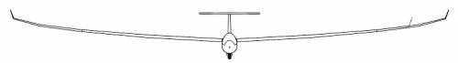
- The total weight of the glider below is 500kg. How much lift must each of the main wings produce to keep the glider airborne

500kg Gravity = 10ms⁻²

- What two consequences do you think would happen to the same glider if the lift on the left wing was 2600N and the lift on the right wing was 2700N

2700N 2600N
500kg Gravity = 10ms⁻²

Consequence 1 …………………………………………………………………………………………
…………………………………………………………………………………………………………….
Consequence 2 …………………………………………………………………………………………
…………………………………………………………………………………………………………….

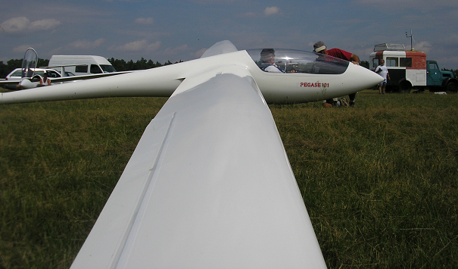
Gliders and powered aircraft are all controlled identically using aileron, elevator and rudder. Some also have flaps which give reduced landing and climbing speed and better performance when high speed cruising.
Glider pilots change the shape of the wings in flight using the control stick which moves the aileron on each wing – the ailerons work in opposite directions. For example, moving the stick to the left:
- lowers the right aileron creating more lift on the right wing
- raises the left aileron reducing lift on the left wing
With more lift on the right wing, the glider rolls to the left and so turns left.
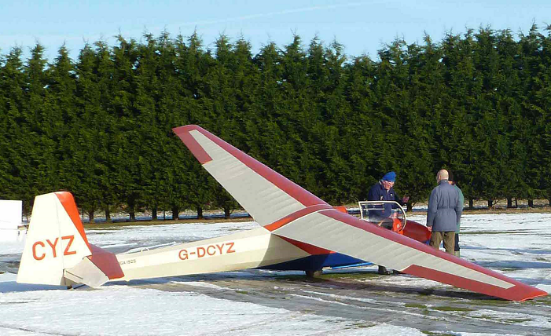
Aileron

(red on rear of wing in lower pic)

The small ‘wing’ at the back of the glider is known as the tailplane. The tailplane stabilises the glider; the elevator is the moveable rear part and moves up and down as the pilot moves the control stick backward and forward. This controls whether the nose of the glider pitches (points) up or pitches down.
Elevator (painted white) moves Tailplane stabiliser (painted red) is fixed
- What do you think would happen to the nose of the glider if the shape of elevator was changed to give the tailplane more lift? Which way would you need to move the elevator to increase the lift?
………………….…………………………………………………………………………………………
…………………………………………………………………………………………………………….
The vertical rudder (painted with the glider’s radio callsign CYZ) has a fixed part (with the Z) which is a vertical stabiliser keeping the glider pointing in line with the airflow – a bit like a weather vane – and a moveable part (painted CY) used for manoeuvring. Unlike a boat, the rudder doesn’t turn an aircraft.
If you have enough time – try changing the shape of the test wing to see how the lift changes. Make the wing shape ‘fatter’ and ‘thinner’.

